**NDEJJE VIEW PRIMARY SCHOOL**

**LESSON NOTES FOR LITERACY 1 PRIMARY ONE**

TERM I

Theme 1: Our school:

Introduction:

*A school is a place where we go to learn.*

*My school is HORMISDALLEN primary school.*

*The headteacher of my school is Mr. Birungi Samuel and the director is KIZITO Mukalazi.*

*Location of the school*

*Hormisdallen school Kyebando is found in Uganda, Kampala district, Kawempe urban council in Kyebando parish Erisa village off Gayaza road.*

*People who serve us at school and what they do.*

*Many people work at school. These include;*

* *Headteacher*
* *Bursar*
* *Secretaries*
* *Cleaners*
* *Matrons*
* *Cooks*
* *Office messenger*
* *Nurses*
* *Deputy headteacher*
* *Store keeper*
* *Director*
* *Security guards*

*Roles of people at school*

* *Headteacher- Heads teachers*
* *Promotes unity in the school.*
* *Supervises the teachers and other workers in the school.*
* *Deputy head teacher: Organizes examination.*
* *Carry out other duties assigned by the headteacher.*
* *Acts in the absence of the headteacher.*
* *Teachers:*
* *Teach children*
* *Guide and council children*
* *Promote discipline*
* *Care for pupils.*
* *Bursar*
* *Collects paid in bankslips.*
* *Collects fees*
* *Banks money (fees)*
* *Pays workers*
* *Cleaners:*
* *To keep the school clean*
* *Cooks:*
* *To serve pupils food.*
* *To clean utensils*
* *To cook food.*
* *Matrons:*
* *To (takecare) of pupils at school*
* *To wash pupils clothes*
* *To clean the dormitory*
* *To teach pupils morals.*
* *Secretaries:*
* *Type exams and letters*
* *To welcome visitors*
* *Store keeper: Keeps school property*
* *Security guards:*
* *Guard the school*
* *Protect the school property*
* *Director: Plans for the school.*

*Things found in the school environment.*

*Buildings, furniture, animals., vehicles, play materials. birds, utensils,. stationery, taps, water tanks etc.*

*Uses of things found in the school environment.*

*Examples of buildings at school and their uses.*

* *Latrines: - For defecating or urinating in*
* *Kitchen – for cooking from*
* *Classroom - For learning from.*
* *Dormitories – For sleeping in*
* *Store – for keeping in food.*
* *Library – For keeping in school textbooks.*
* *Sick bay – It is where children go for medical care.*
* *Offices – It is where the headteacher , deputy, bursary and secretaries do their work from.*
* *Dinning room- It is where children have meals from.*
* *Bathroom – For bathing from.*

*Examples of stationery and their uses.*

* *Books – for writing in and for reading.*
* *Pens/ pencils – For writing*
* *Coloured pencils – For shading*
* *rulers – For drawing lines*
* *Rubbers- For rubbing*
* *Papers – For writing on*

*Examples of furniture at school and their uses.*

* *Desks – For sitting at.*
* *Benches – for sitting on.*
* *Tables – For putting on books while writing.*
* *Cupboard – for keeping in books.*
* *Chairs – For sitting on.*
* *Shelves – for keeping in books.*

*Examples of utensils at school*

* *Forks, Spoons, cups, plates, saucepans and buckets.*

*Uses of other things at school*

* *Vehicles - For transporting children.*
* *Brooms - for sweeping*
* *Water tanks – for keeping water.*
* *Playground – for playing from*
* *Tap – to provide water.*
* *Fence – For security*
* *Buildings – for shelter*
* *Posts – For guidance*

*People who work at school and places where they work*

* *Headteacher*
* *Bursar office*
* *Deputy headteacher& secretaries*
* *Cleaners - compound*
* *Cooks – Kitchen*
* *Teacher – classroom*
* *Gatekeeper – gate*
* *librarian – library*
* *dormitory – matron*

*Things found in the classroom and their uses.*

* *Books – For writing in.*
* *Pencils – for writing*
* *Duster – For cleaning the chalkboard*
* *chalk – for writing on the chalkboard*
* *Blackboard – for writing on work.*
* *Broom – for sweeping*
* *Rag – For mopping*
* *Desk - For sitting on*
* *Table - for putting on books while writing.*
* *Shelf – For keeping in books.*
* *Bench - For sitting on.*
* *Chairs – For sitting on.*
* *Ruler – For drawing lines.*
* *Charts - For reading*
* *Rubber – For rubbing in books.*
* *Coloured pencils – For colouring / shading pictures.*

*Activities done at school.*

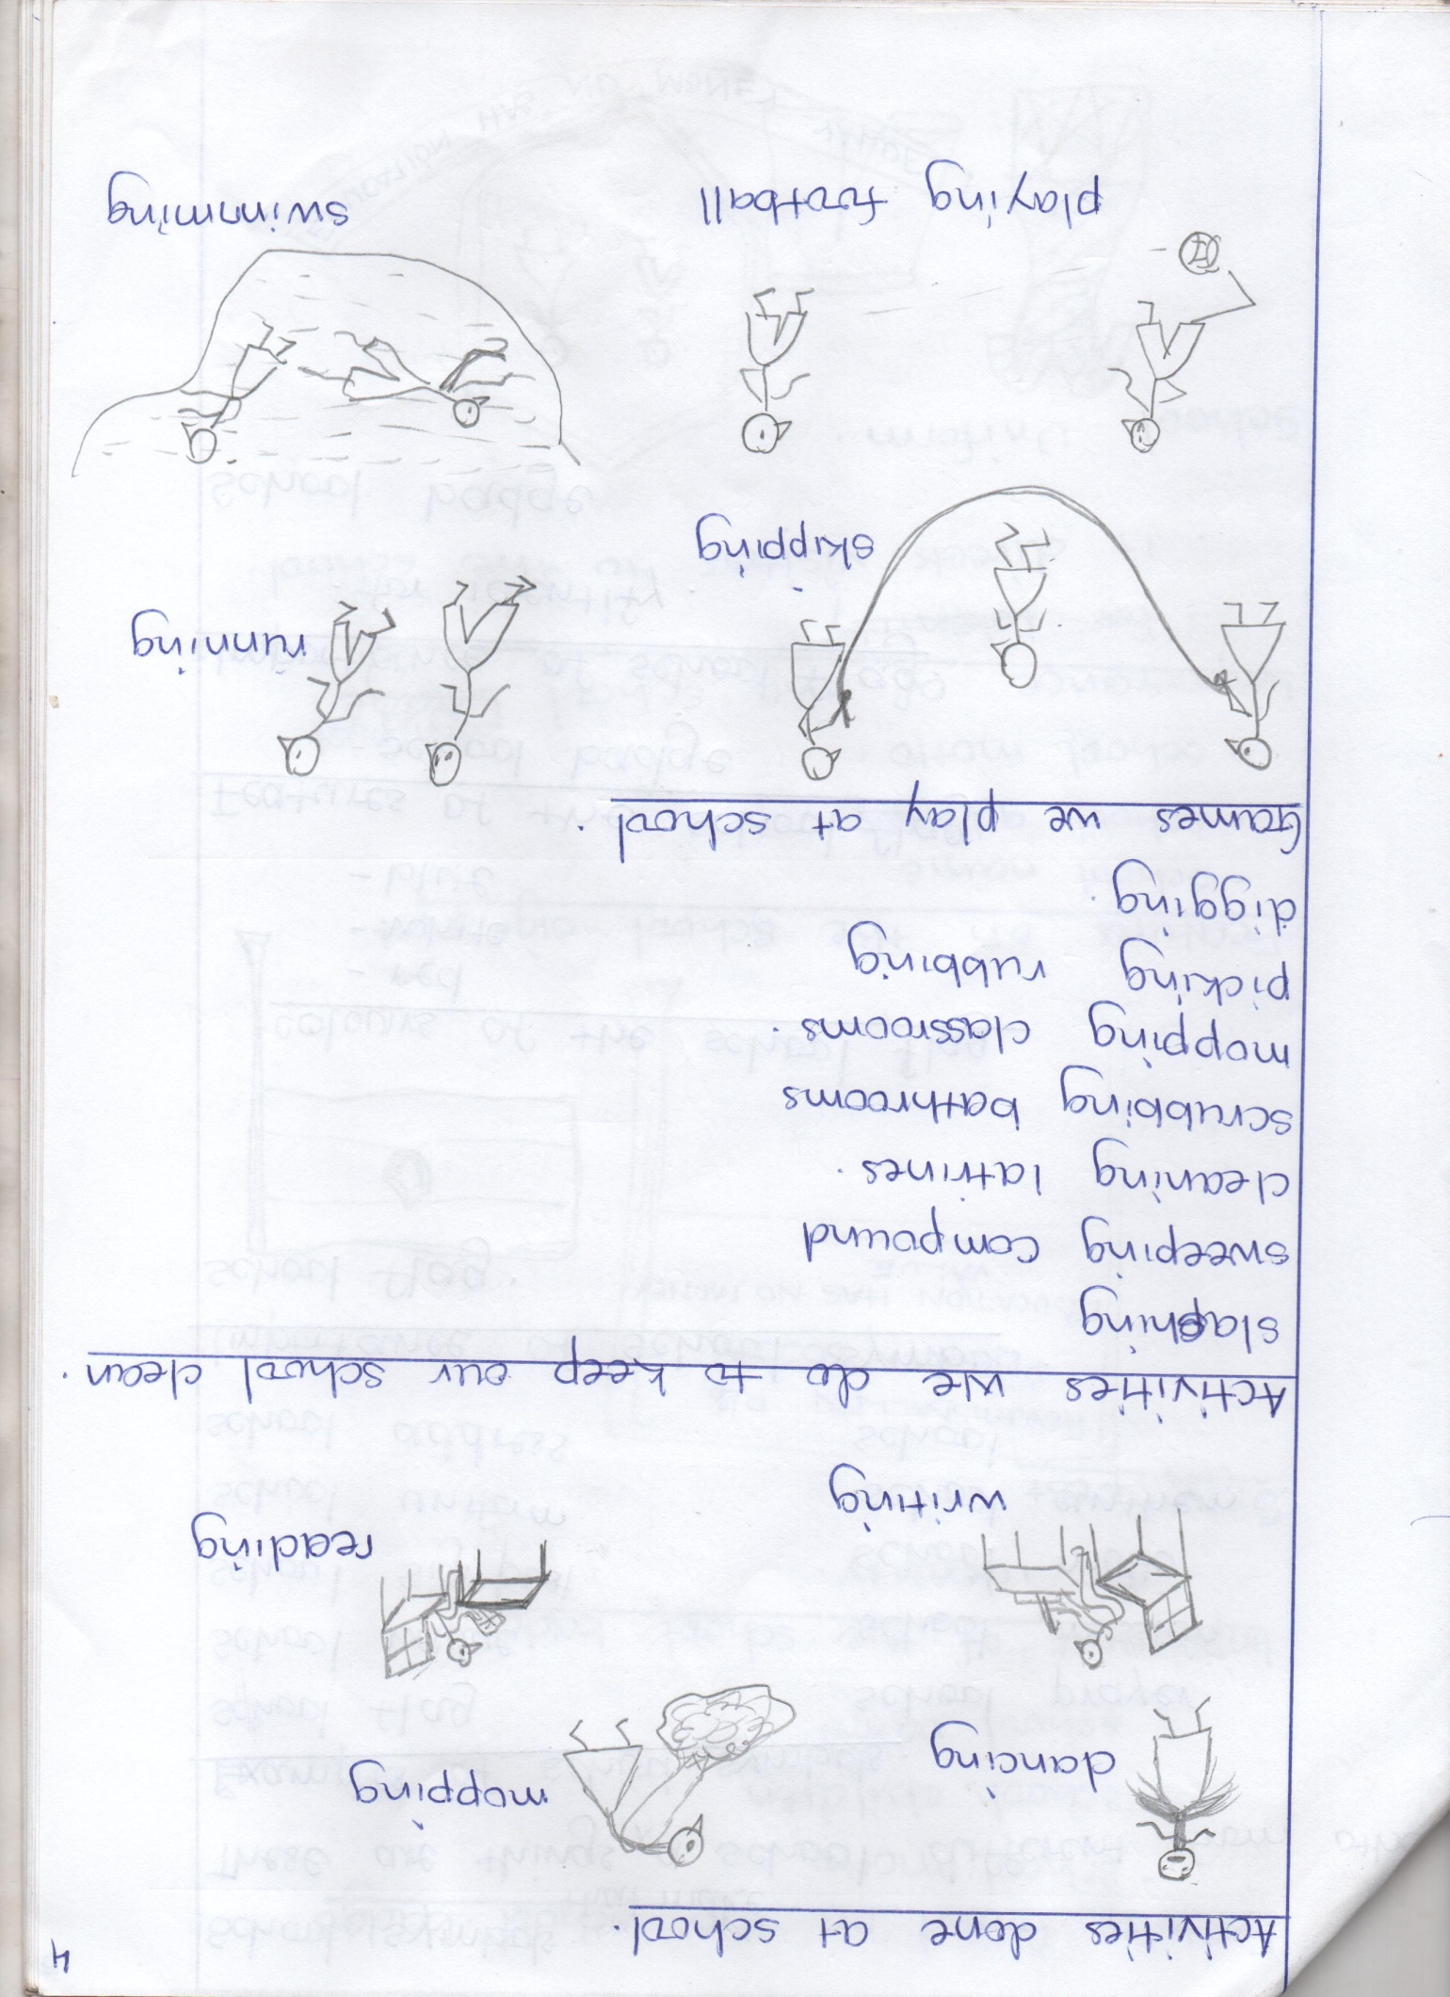

* *Praying*
* *Colouring*
* *Gardening*

*Activities we do to keep our school clean.*

* *Slashing*
* *sweeping latrines*
* *Scrubbing bathrooms*
* *Mopping classrooms*
* *picking rubbish*
* *digging*

*Games we play at school*

* *Playing netball*
* *Valley ball*

*School symbols.*

*These are things that make a school different from others.*

*Examples of school symbols.*

* *School flag*
* *school badge*
* *School sign post*
* *School uniform*
* *School address*
* *School prayer*
* *School mission*
* *School motto*
* *School anthem*
* *School*

***Importance of school symbols.***

*School flag.*

*colours of the school flag.*

* *Red*
* *White*
* *Blue*

*Features of the school flag*

* *School badge*

*Importance of the school flag.*

* *For identity*

*School badge*



*Features found on the school badge.*

* *School motto*
* *School children*
* *School name.*

*Importance of the school badge*

* *For identity*

*Sign post*

*Hormisdallen P/S*

*P.O.Box 30223, kampala*

*Education has no money value*

*Features on the school sign post.*

* *School name*
* *school address*
* *School motto*

***Importance of the school sign post***

* *It directs visitors to the school*

*School uniform.*

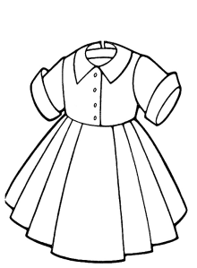

*Colours of the school uniform*

* *Blue*
* *white*
* *red*

*Importance of the uniform.*

* *It makes children look smart.*
* *For identity.*

*Ways of keeping the school clean.*

* *By removing cobwebs*
* *By picking rubbish*
* *By burning rubbish*
* *By mopping*
* *By sweeping classrooms, dormitories & compound.*
* *By scrubbing latrines.*
* *By painting walls.*
* *By digging the bush on the compound.*

*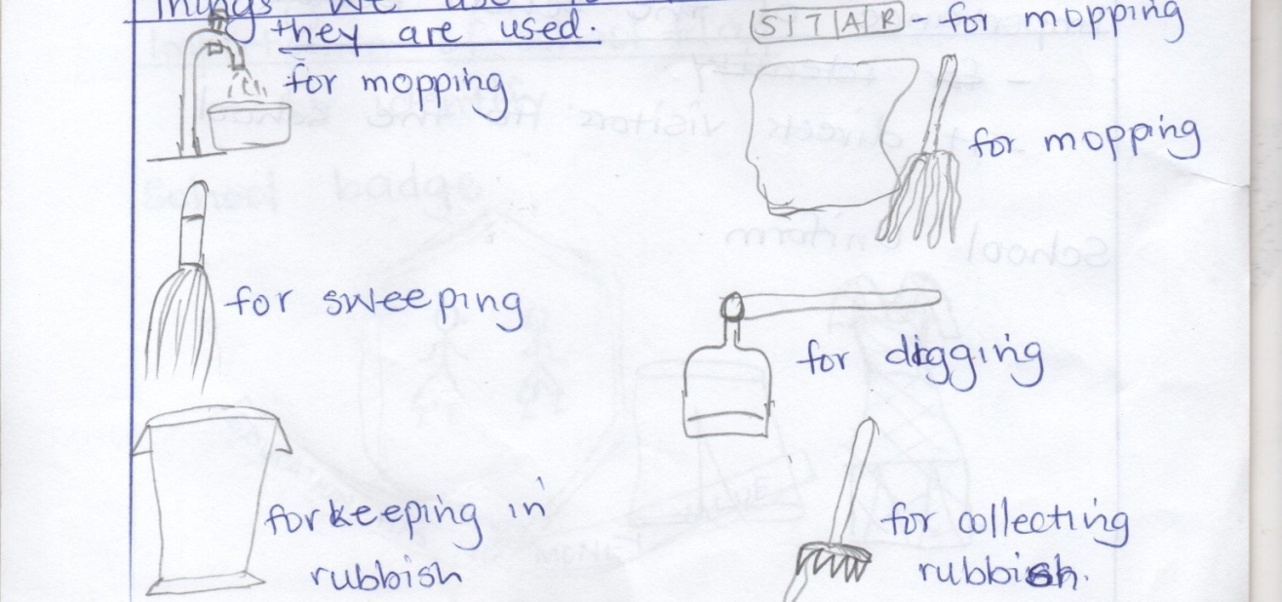Things we use to clean the school and how they are used.*

*Needs of a school.*

*A school needs many things like;*

* *books*
* *textbooks*
* *chalk*
* *utensils*
* *furniture*
* *buildings*
* *water*
* *uniforms*
* *computers*
* *play materials.*
* *wall clock*
* *vans*
* *play ground*
* *pencils*
* *food*
* *electricity*
* *money*
* *rulers*

*Sources of school needs*

* *parents - farms*
* *markets - friend (donors)*
* *shop*
* *banks*

*School property*

*These are things that belong to the school*

* *Wall clock*
* *vans*
* *buildings*
* *chalk*
* *play materials*
* *utensils*
* *computers*
* *furniture*
* *textbooks*
* *utensils*
* *Garden tools.*

*Ways of caring for school property.*

* *By washing plates and cups.*
* *By keeping textbooks in shelves.*
* *By dusting tables.*
* *By cleaning classrooms*
* *By repairing vehicles.*
* *By repairing computers.*
* *By cleaning garden tools after use.*

***Personal property.***

*These are things that belong to a particular person.*

*Examples include;*

* *bags, books, pens, pencils,. mattresses, books, uniforms, bedsheets, rubbers.*

*Caring for personal property.*

* *By keeping books in shelves.*
* *By washing uniforms and bedsheets*
* *By keeping pencils in bags.*
* *By polishing shoes.*

***Neighbouring schools.***

*A neighbour is a person near me.*

*Neighbouring schools are schools near our school.*

*Examples of neighbouring schools.*

* *Sunlight P/s, Kampala Quality P/s, Serena P/s, Hajara p/s, etc*

***Safe ways to and from school.***

* *Moving in groups.*
* *Cross from the zebra crossing*
* *Do not play on the road*
* *Walk from the footpath*

***Ways of going to school;***

* *By car*
* *By a motorcycle On foot*
* *By a bus*

***Dangers on the way to school.***

* *Animals bites*
* *Knocked by a car*
* *Insect stings*
* *Made people stone people.*
* *Falling off a tree*
* *Drowning*

***Causes of road accidents***

* *Playing on the road.*
* *Bad roads*
* *Over loading*
* *Untrained drivers*
* *Drunken drivers.*

***Road signs:***

*These are things that guide road users on the road.*

*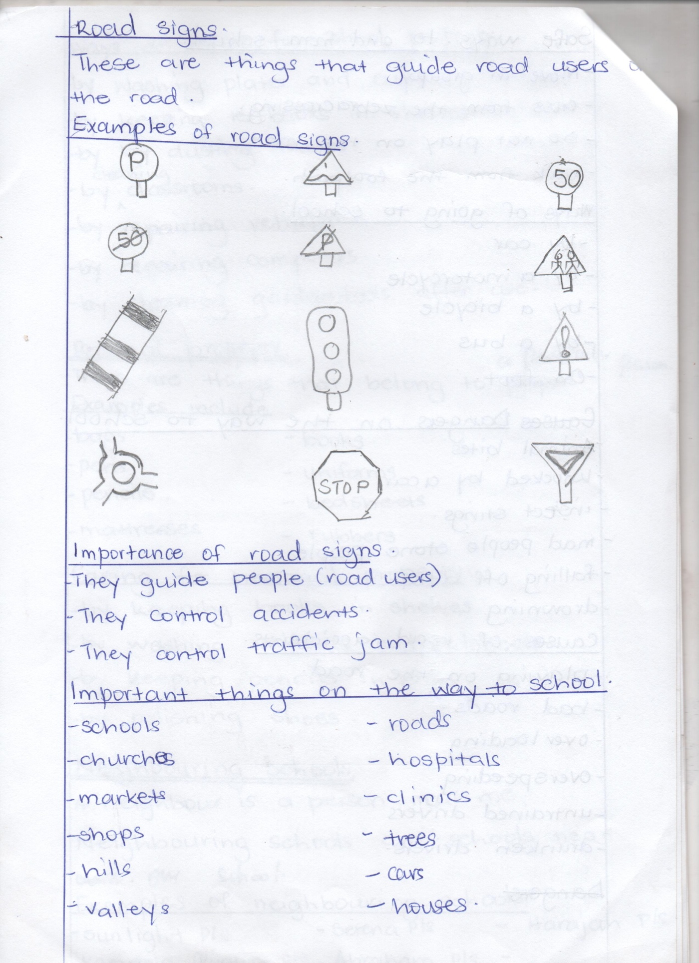Example of road signs.*

***Importance of road signs.***

* *They guide people (road users)*
* *They control accidents*
* *They control traffic jam*

*Important things on the way to school*

* *Schools*
* *Churches*
* *markets*
* *shops*
* *hills*
* *valleys*
* *roads*
* *hospitals*
* *clinics*
* *trees*
* *houses*

***Theme: II our home***

*A home is a place where we live.*

*People at home.*

* *Father Niece cousin*
* *Mother nephew grandfather*
* *Sister uncle grand mother*
* *brother aunt*

***Father and mother start a home /family****.*

*Types of families*

*A family is a group of people living together related by blood or marriage.*

* *A nuclear family is a family having father , mother and their children.*
* *An extended family is a family having father, mother, their children and other relatives.*

*Relatives in a family.*

* *aunt, grandmother, nephew, grandmother, uncle, niece, cousin*

*Roles of family members.*

*Father:*

* *Buys food*
* *buys clothes*
* *disciplines children*
* *pays family members*
* *pays house rent*

*Mother:*

* *cooks food.*
* *Washes clothes*
* *cleans the home*
* *buys food*
* *buys clothes*
* *disciplines children*

*Children:*

* *They fetch water.*
* *They help in cooking*
* *They wash utensils.*
* *They wash clothes*
* *They clean the home.*
* *They collect firewood.*

*Family relationships.*

* *Father and mother are my parents.*
* *The father of my parents in my grandfather*
* *The mother of my parents is grandmother.*
* *The sister of my parents is my aunt.*
* *The brother of my parents is my uncle.*
* *The child of my uncle/aunt is my cousin.*
* *The son of my brother/sister is my nephew.*
* *The daughter of my brother /sister is my niece.*

***Wrong people at home.***

*Rapists - abductors*

*Kinappers - defiles*

*Murderers - drunkards*

*Smokers*

*thieves*

*Bad behaviour done at home.*

* *Stealing*
* *Fighting*
* *Quarrelling*
* *Smoking*
* *Stoning*
* *Burning property at home.*

*Activities done at home.*

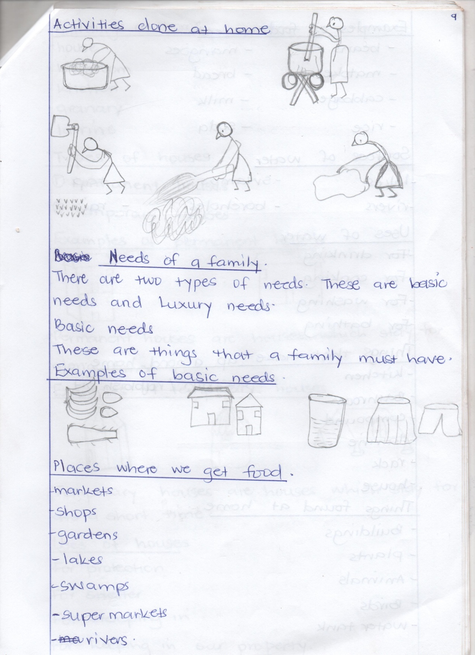

***Needs of a family.***

*There are two types of needs. These are basic needs and luxury needs.*

*Basic needs.*

*These are things that a family must have.*

*Examples of basic needs.*

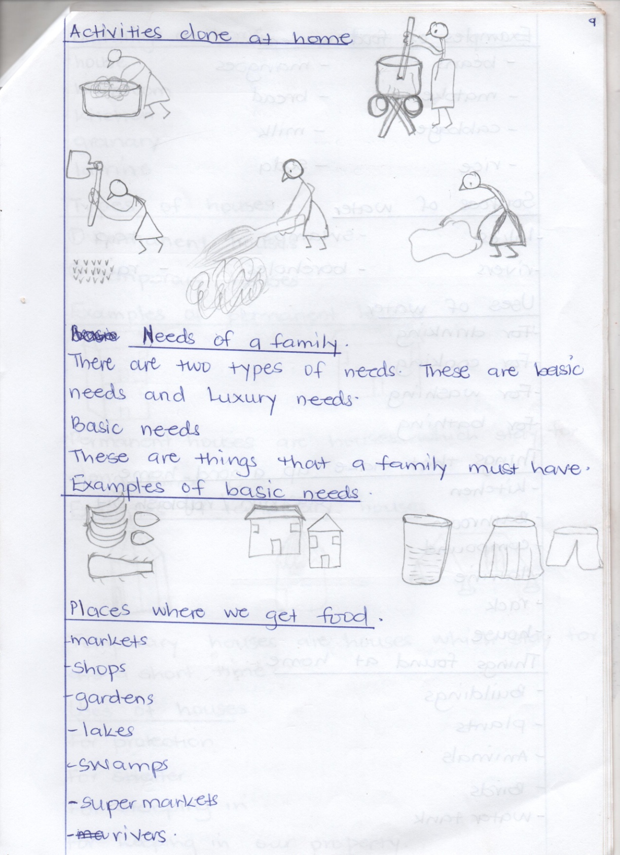

*Places where we get food.*

* *Markets*
* *Shops*
* *Gardens*
* *Lakes*
* *Swamps*
* *Super markets*
* *Rivers*

*Examples of food we eat.*

* *beans, mangoes, matoke, bread, cabbage, milk, rice, soda.*

*Sources of water.*

* *Lakes*
* *rivers*
* *swamps*
* *boreholes*
* *tap*
* *rain*

*Uses of water.*

* *For drinking*
* *For cooking*
* *for washing*
* *For bathing*

*Thing that make up a good home.*

* *Kitchen*
* *Bathroom*
* *Compound*
* *Latrine*
* *rack*
* *House*
* *Dustin/ rubbish pit*

***Things found at home***

* *Buildings*
* *Plants*
* *Animals*
* *Birds*
* *water tanks*
* *compound*

***Things found at home.***

*Animals kept at home (Domestic animals)*

* *dogs - rabbits*
* *goats - cows*
* *cats - sheep*
* *horses -*
* *donkeys*
* *camels*
* *pigs*

*Uses of domestic animals.*

* *Cats chase away rats*
* *Dogs guard our homes*
* *Dogs are used for hunting*
* *Donkeys, camels and horses are used for transport*
* *Cows provide milk and beef*
* *Some domestic animals provide skins and hides*
* *We get wool and mutton from sheep.*

*Ways of caring for domestic animals.*

* *By treating them*
* *By providing shelter*
* *By cleaning their shelter*
* *By feeding them*

*Uses of water to animals.*

* *For drinking*
* *For cleaning their homes*
* *For washing them*

*Birds kept at home (domestic animals)*

* *Hens*
* *Cocks*
* *Turkeys*
* *Ducks*
* *Geese*
* *Pigeons*

*Uses of domestic birds*

* *Birds provide feathers*
* *We sell them and get money*
* *Birds provide meat*
* *Birds provide eggs*

*Caring for birds*

* *By feeding them*
* *By treating them*
* *By providing shelter*
* *By cleaning their shelter*

*Plants found at home.*

*Trees; like*

* *Mango*
* *Orange*
* *Pawpaw*
* *Jackfruit*
* *Coconut*

*Crops like;*

* *Cabbage*
* *Tomatoes*
* *Beans*
* *Bananas*
* *Maize*
* *Potatoes,*
* *Groundnuts*
* *Sim sim*
* *Millet etc*

*Grass like paspalum*

***Uses of plants***

* *Plants like grass are sources of food to animals*
* *Some plants provide medicine*
* *Some plants provide shade*
* *Some plants provide fruits*
* *We get firewood from some plants*
* *Some plants are used to make timber.*

*Buildings at home.*

* *House*
* *Bathroom*
* *Kitchen*
* *granary*
* *Latrine*

*Types of houses*

* *Permanent houses*
* *Temporary houses*

*Examples of permanent houses*

*Bungalow Storeyed*

*Permanent houses are housed which stay for a long time.*

*Examples of temporary houses.*

* *Tent,*
* *kiosk*
* *Hut*
* *Unipot*

*Temporary houses are houses which stay for a short time.*

*Uses of houses.*

* *For protection*
* *For shelter*
* *For sleeping in.*
* *For keeping in our property.*

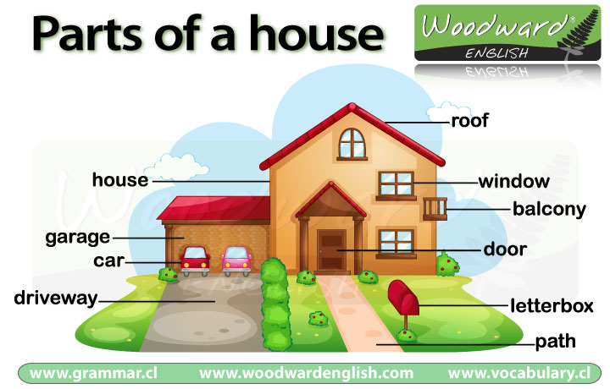

*Rooms in a house and their uses.*

* *Bedroom – For sleeping in.*
* *Kitchen - For cooking from.*
* *Latrine – For defecating in.*
* *Dining room – For having meals from.*
* *Sitting room - For sitting in.*
* *Store – For keeping food stuffs*
* *Garage – For keeping in the car.*
* *Bathroom – For bathing from.*
* *Study room – for reading from*

*Things found in the house.*

* *Bedroom- beds, bed sheets, blankets, clothes.*
* *Sitting room – Mats, chairs, tables, cupboard*
* *Kitchen – cups, plates, saucepans, buckets, pot, charcoal, store, spoons, forks, mortar, pestle.*
* *Latrine – Scrubbing brush, water, soap.*
* *Garage – Car, bicycle, motorcycle.*
* *Store – Food , charcoal, garden tools.*
* *Diningroom - Cupboard, fridge, chairs, table.*

*Caring for things in the house.*

* *By washing plates and cups.*
* *By keeping utensils in the cupboard.*
* *By washing clothes*
* *By repairing chairs.*
* *By dusting furniture in the house.*

***Building materials.***

*These are things used to build a house.*

*Types of building materials.*

*Modern building materials.*

*These are materials used to build strong houses.*

*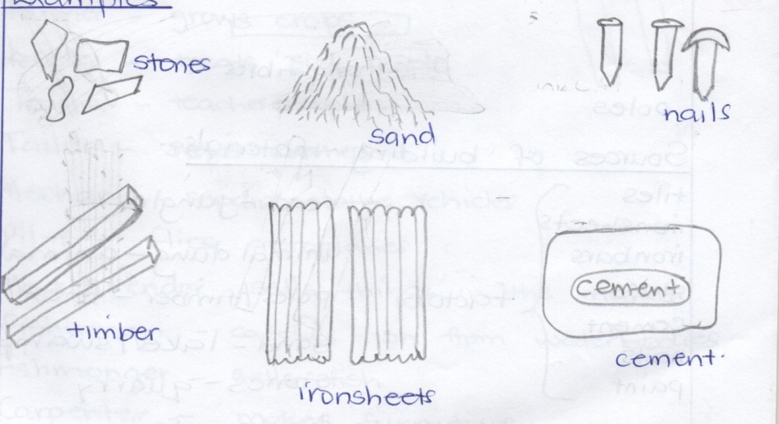Examples.*

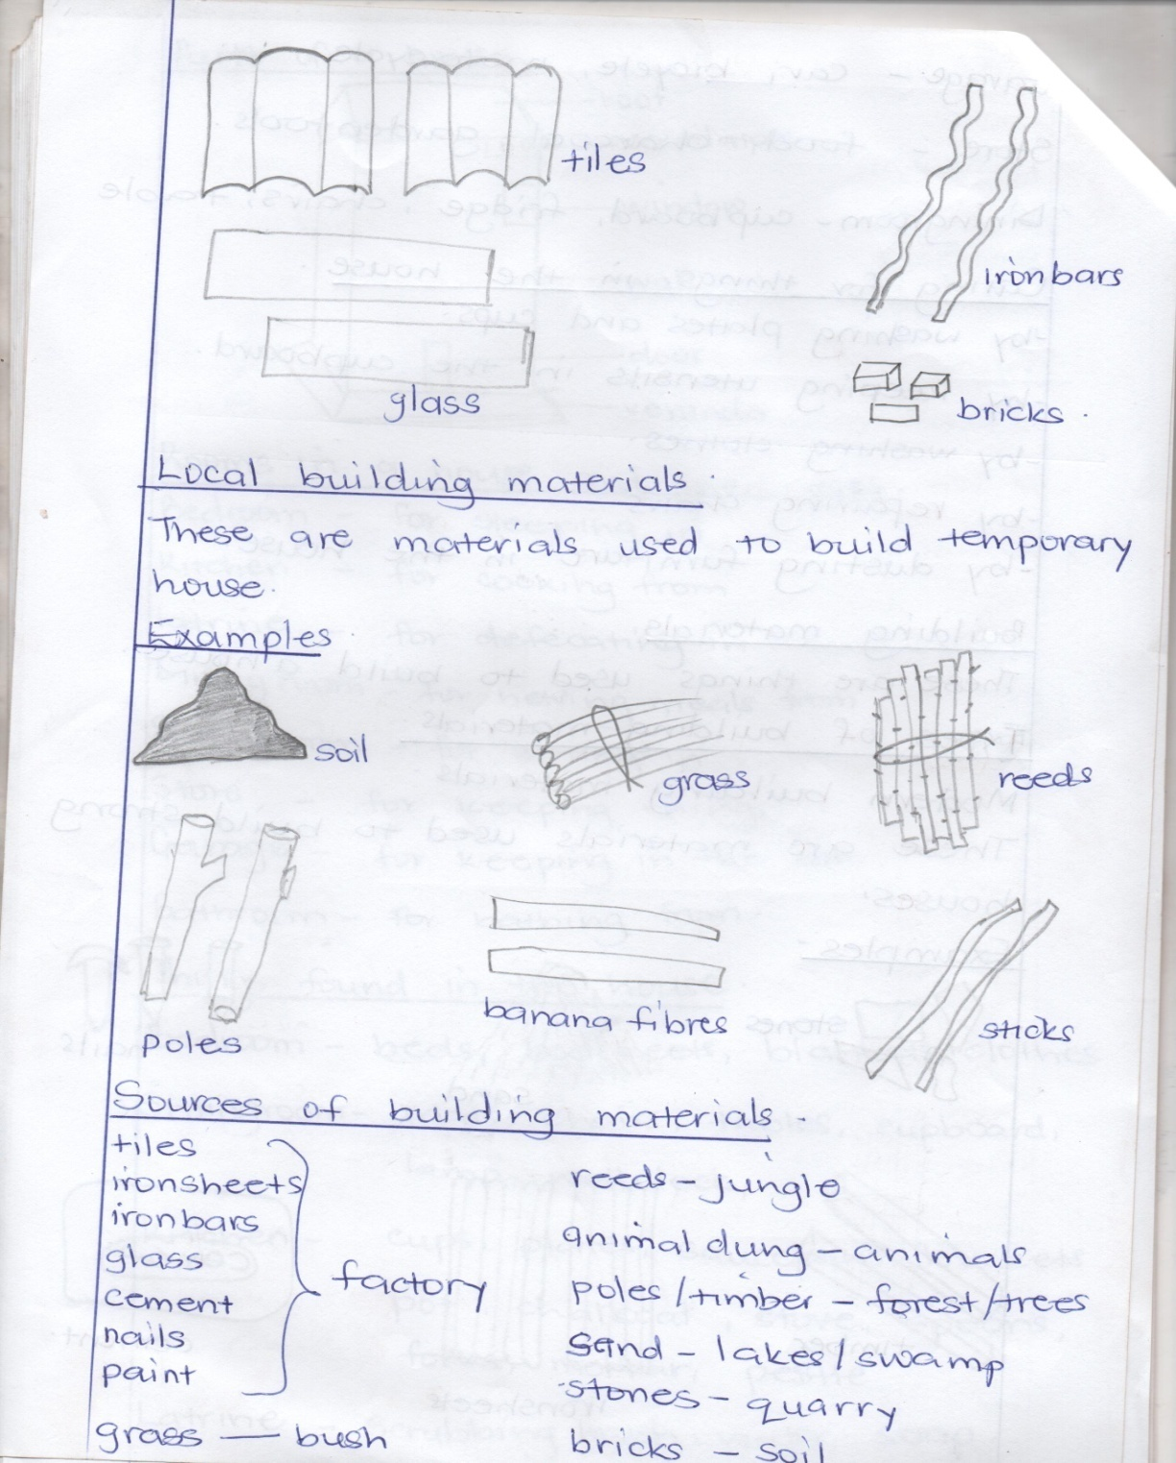

***Local building materials.***

*These are materials used to build temporary house.*

*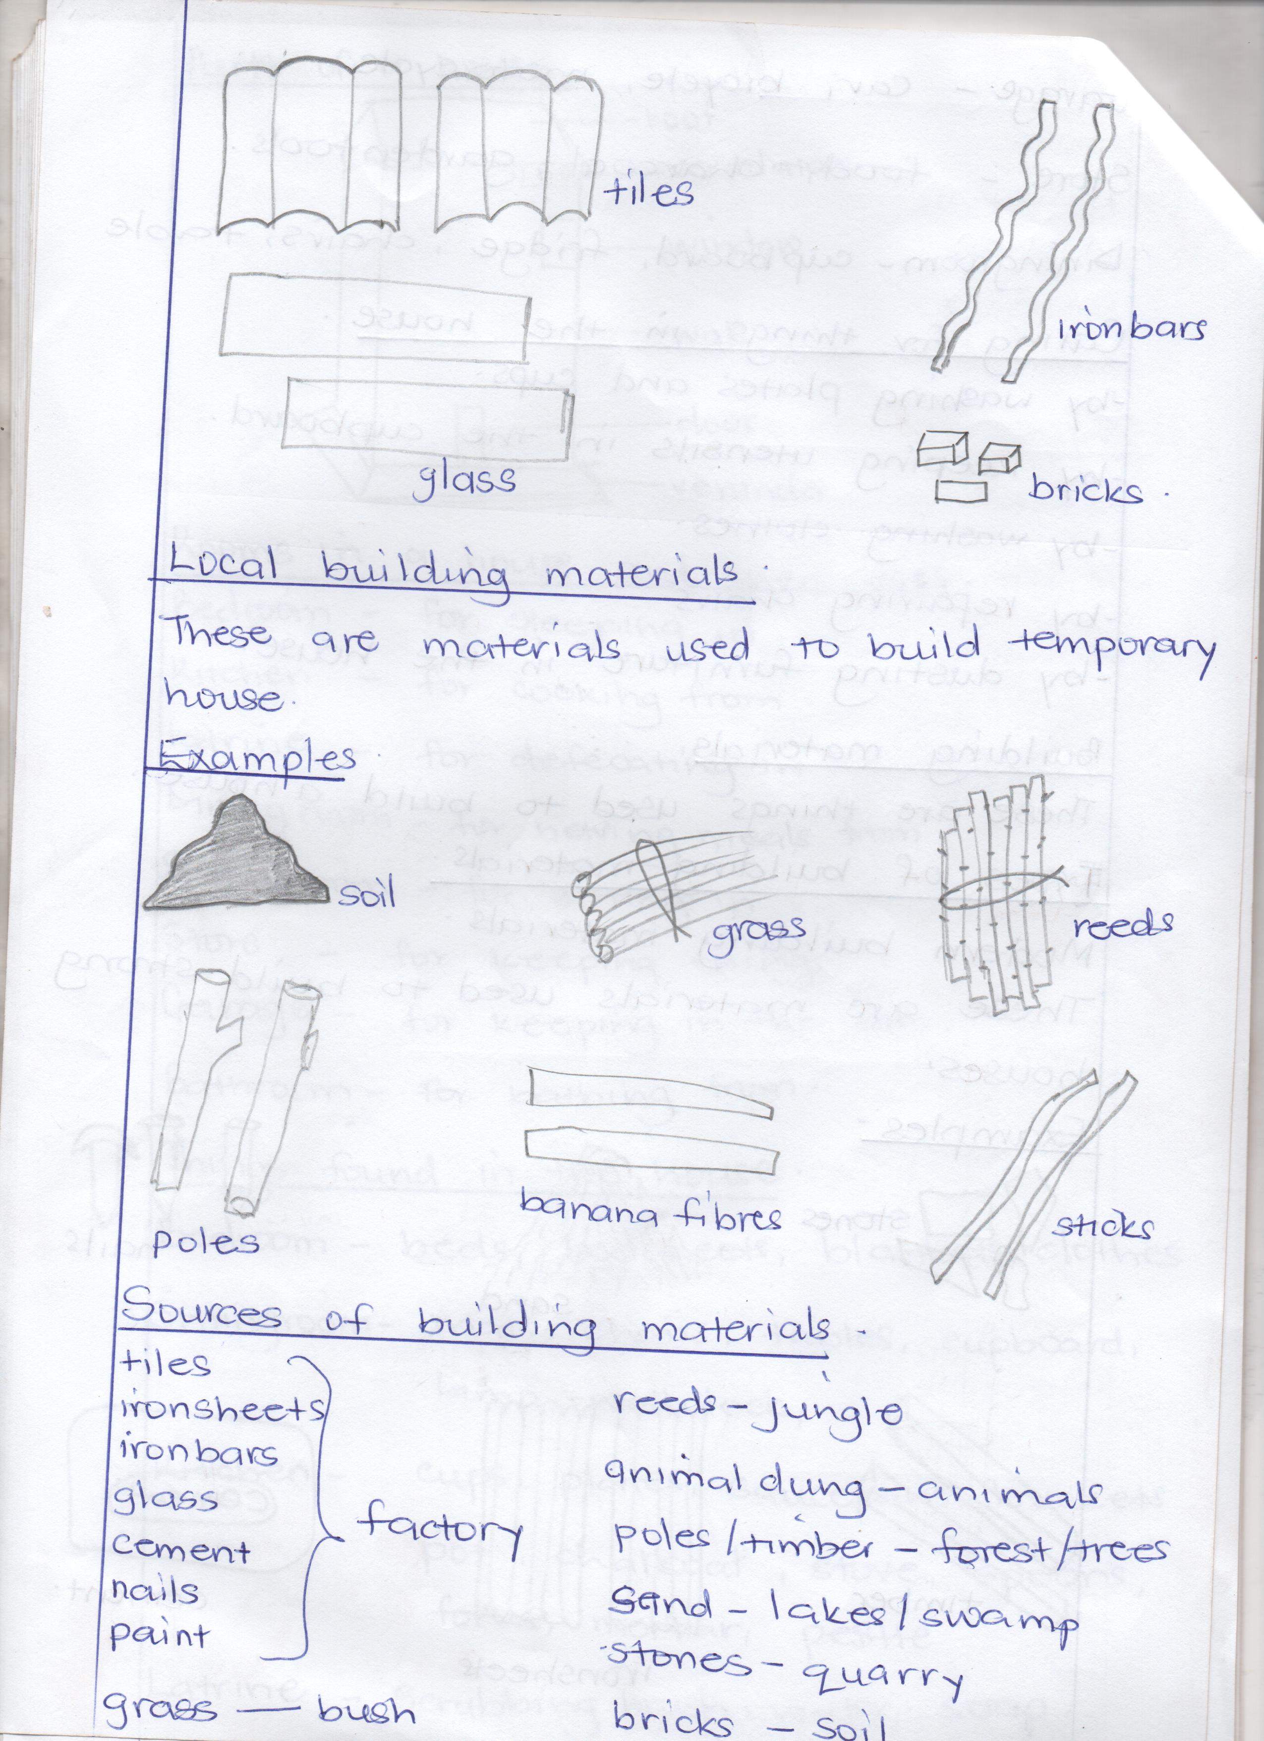Examples.*

*Sources of building materials.*

*tiles Reeds - jungle*

*ironsheets animals dung - animals*

*ironbars poles /timber – forest/ trees*

*glass factory sand – lakes / swamps.*

*cement stones - lakes / swamp*

*nails bricks – soil.*

*paint*

*grass – bus*

***THEME III: OUR COMMUNITY:***

*A community is a group of people living and working together.*

*Examples of communities.*

* *Market community, Church community, Mosque community,*
* *Bank community, garage community, home community, village community*
* *School community, town community,Police community*
* *Hospital community*

*People in the community and their occupation.*

* *Barber – cuts people’s hair.*
* *Cobbler – repairs shoes.*
* *Farmer – grows crops*
* *Doctor – treats people.*
* *Teacher – teaches people.*
* *Tailor – sews clothes.*
* *Mechanic – repairs vehicles.*
* *Pilot – Flies aeroplanes.*
* *Market vendor - sells things in the market.*
* *Fisherman – catches fish from water bodies.*
* *Fishmonger – sells fish.*
* *Carpenter – makes furniture.*
* *Priest – Leads prayers in church*
* *Imam- Leads prayers in the mosque*
* *Policeman – Keeps law and order*
* *Nurse – cares for sick people*
* *Banker – gives out money in the bank.*
* *Shopkeeper – sells things in the shop.*
* *Butcher – sells meat.*
* *Chef – cooks food in the hotel.*

***People in the community and their places of work.***

* *Priest - church*
* *Imam – mosque*
* *Policeman – police station*
* *Nurse*
* *Doctor hospital*
* *Banker - bank*
* *shopkeeper - shop*
* *butcher – butcher’s*
* *chef - hotel*
* *barber - barber’s*
* *cobbler - workshop*
* *farmer - farm*
* *Teacher – school*
* *Pilot – airport*
* *Mechanic - garage*
* *Carpenter - workshop*
* *Market vendor – market*
* *Grocer – grocer’s*

***Activities done in the community.***

* *Fishing, keeping cattle, farming , trading, building, washing, mining, circumcision, marriage etc.*

***Important places in the community.***

* *School, hospital, post office, radio station. market, church, mosque, bank, police station, airport, shop, garage, recreation centre, farm.*

*Tools used by people in a community.*

*Person Tool*

*Fisherman - Fishing nets, hooks, baskets, spears*

*Farmers - Hoes ,pangas, axes, etc*

*Shop keepers - Weighing scales*

*Police officers - guns, batons, pistols, hand cuffs*

*Pastors, Bishops,*

*Priests, reverends - Bibles*

*Imam, sheik etc - Quarn*

**TERM II& III 2019**

Theme: weather

Sub-theme

* Types of weather
* Elements of weather
* Uses of weather elements
* Dangers of weather makers
* Things used to protect ourselves from bad weather.
* Ways of protecting ourselves from bad weather.
* Activities done in each type of weather.
* Types of seasons
* Activities for different seasons.
* Garden tools
* Uses of garden tools.

Theme 2 : Our transport

Sub themes:

* Types of transport
* Means of transport
* People who operate transport means.
* Places where transport means are found / parked.
* Importance of transport
* Road safety
* Cayuse of road accidents
* Ways of controlling road accidents
* Effects of accidents
* Road signs
* Importance of road signs
* Road users

**Theme 3: Things we make.**

Sub themes:

* Thing we make at home
* Things we make at school
* Raw materials used to make things
* Things we make from different materials.
* Sources of raw materials used to make things
* Importance of things we make.

Term III

Theme 1: Peace and security

Sub themes:

* People who keep peace and security
* Examples of religious leaders.
* Roles of people who keep peace and security
* Factors that promote peace and security in our homes
* causes of insecurity in our homes
* Factors that promote peace and security in our school.
* Causes of insecurity at school
* Effects of insecurity
* Importance of insecurity.
* Things used to keep peace and security.

**TERM II & III, 2019**

THEME 1: WEATHER.

Weather is the condition of atmosphere at a given time.

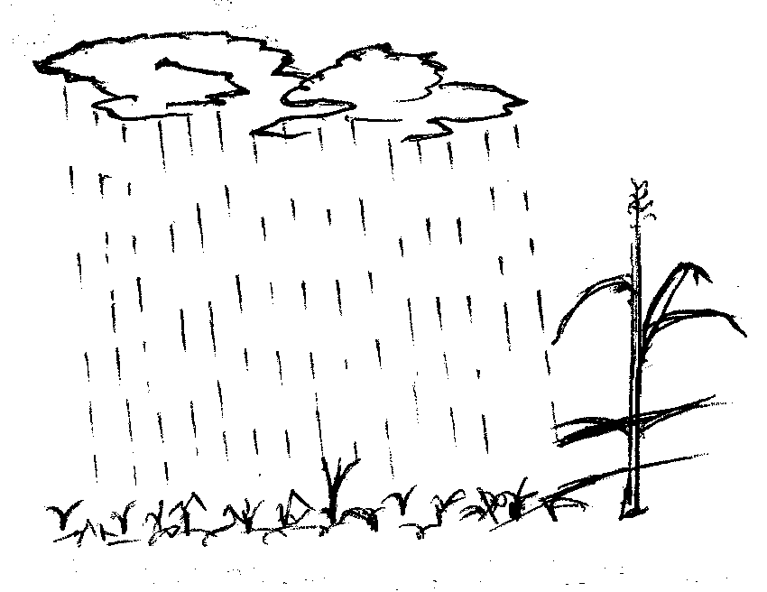Types of weather.

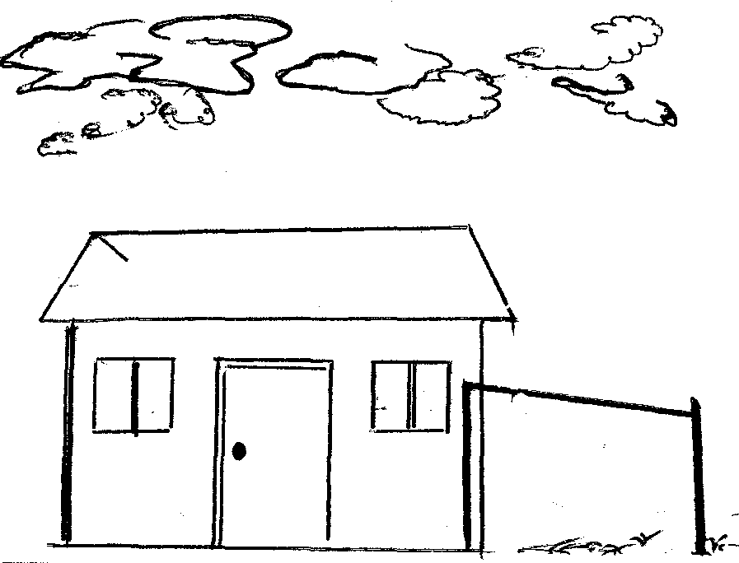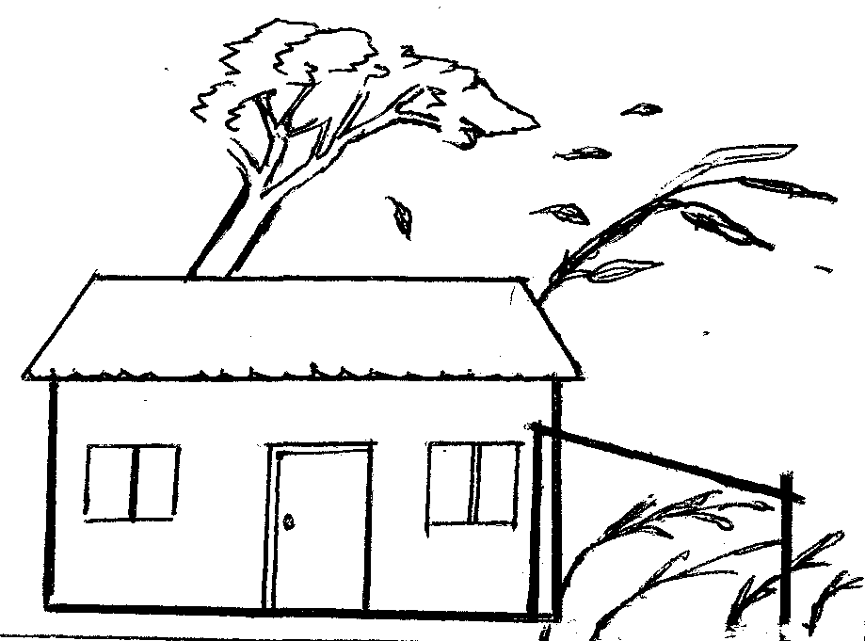

Rainy cloudy windy

**Elements of weather**.

These are things that make up weather. They can also be called factors, aspects or weather makers.

Examples include.

* Wind
* rain
* cloud cover
* sunshine
* humidity
* temperature
* air pressure

Uses of weather elements

Wind:

Wind is moving air.

Uses of wind.

* It takes away bad smell.
* It pollinates flowers
* It flies kites
* It drives windmills
* It helps boats to move on water
* It dries clothes
* It helps winnowing
* It supports burning.

**Dangers of too much wind.**

* It causes accidents
* It raises dust
* It spreads diseases
* It destroys houses
* It spoils crops
* It breaks trees

**How to manage wind.**

* By taking shelter
* By keeping ourselves and things in doors
* By planting trees to act as wind breakers

**Rain:**

Rain is the main natural source of water.

**Uses of rain.**

* It gives us water
* It makes the soil soft
* It helps plants to grow
* It reduces dust
* It adds water into water bodies.

**Dangers of too much rain.**

* It spreads diseases
* It spoils houses
* It destroys crops
* It wets our property
* It causes floods
* It makes roads slippery
* It kills people and animals.
* It causes accidents
* It causes soil erosion
* It leads to land slides

**How to protect ourselves from rain.**

* By using umbrellas
* By wearing gumboots
* By wearing rain coats
* By taking shelter

**Things used to manage rain**

* Umbrellas
* Raincoat
* Gumboots
* Banana leaves

**Clouds**

**Examples of clouds**

* Nimbus clouds
* Stratus clouds
* Cumulus clouds
* Cumulo-nimbus clouds
* Cirrus clouds

The farthest clouds in the sky are the cirrus clouds

Nimbus clouds give us rain.

**Uses of clouds.**

* They give us rain.
* They protect us from direct sunshine
* They make the weather cool.

**Dangers of clouds**

* They cause rain storm
* They cause lightning
* They cause air accidents

How to manage cloudy weather.

* People should not take flights
* During cloudy weather

**Sunshine.**

The sun is the main natural source of heat and light. It raises from East and sets in the west.

**Uses of sunshine.**

* We get vitamin D
* It gives us warmth
* It gives us light
* It dries small fish
* It dries clothes
* It dries seeds
* It dries ready crops

**Dangers of too much sunshine**

* It spoils eyes
* It makes the soil hard
* It causes drought
* It causes famine
* It dries water bodies
* It kills animals
* It dries young crops
* It causes too much heat

**How to protect ourselves from sunshine**

* By using umbrellas
* By wearing light clothes
* By wearing hats
* By wearing sunglasses
* By taking shelter in houses and under trees

**Things used to manage sunshine**

* Sunglasses
* Vests
* Caps
* Umbrellas
* hats

Ways plants and animals protect themselves from bad weather.

Plants

* By mulching them.
* by watering them
* by planting trees
* by pruning them
* by terracing them

**Animals**

* by keeping them in shelter
* by giving them enough water
* by treating them
* by planting trees near their homes.

Activities done in each type of weather.

**Types of seasons**

There are two seasons in Uganda. These are;

1. Dry season ii. Wet season

Activities for different seasons

Dry season Wet season

* Preparing land - harvesting water
* Watering plants - planting
* Drying seeds - digging
* Harvesting crops - weeding
* mulching - pruning
* thinning
* spraying

**Garden tools and their uses.**

Hoe - for digging

Watering can - for watering crops

Wheel barrow - for carrying manure

Rake - For collecting rubbish

Axe - For cutting big trees

Panga - For cutting small trees.

Basket - For harvesting crops

Knife - For cutting , peeling, harvesting crops

Spade - For spreading manure

slasher - For slashing

sickle - For cutting grass

Forked hoe - For digging couch grass

Trowel - For transplanting seedlings.

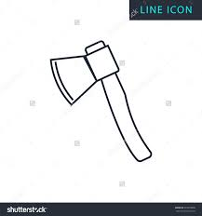Diagrams of tools used.

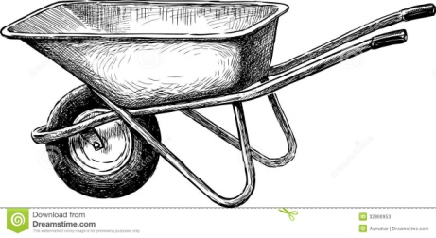

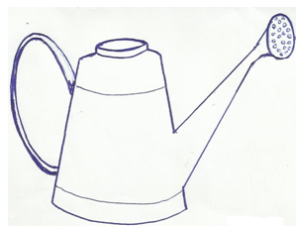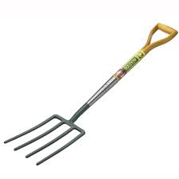

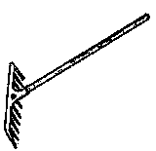

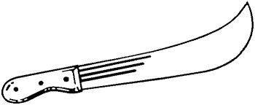

**Theme II: Our environment:**

Transport is the movement of people and goods from one place to another.

Types of transport.

* Water transport
* Air transport
* Railway transport
* Road transport
* Pipeline transport

Means of transport

Water transport

* Ferry - Yacht
* Canoe - boat
* Ship

Air transport

* Aeroplane
* Helicopter
* Jet
* Rocket
* Parachute

Road transport

* car
* bus
* lorry
* bicycles
* tractor
* motorcycle

Road users i.e.

* pedestrians
* drivers
* cyclists

A pedestrian is a person who walks along the road.

A driver is a person who drivers vehicles

A cyclists is a person who rides a bicycle.

People who operate different means of transport.

* Pilot - flies aeroplanes
* captain - sails ships
* Sailor - sails boats
* driver - Drives vehicles
* Engine driver - Drives trains
* Cyclist - Rides bicycles
* Motor cyclist - Rides motorcycles

Places where we find different means of transport

* Aeroplane
* Helicopter Air port
* Jet
* Ship - port
* boat - landing site
* bus - bus park (bus station)
* Taxi - Taxi park
* Train railway station

Importance of transport

* For carrying food
* For carrying clothes
* For carrying people
* For carrying water
* For carrying animals
* For carrying building materials.

Road safety

These are safe ways of using the road.

Examples:

* Cross at the zebra crossing.
* Do not cross the road in a corner.
* Do not run while crossing the road
* Walk in a single file.
* Do not play on the road.

An ambulance is used to carry sick people to the hospital.

**Causes of accidents**

* Playing on the road.
* Bad roads
* Over loading
* Speeding vehicles
* Untrained drivers
* Drunken drivers
* Careless drivers
* Driving vehicles under poor mechanical conditions.

**Ways of controlling accidents**

* Avoid playing on the road
* Avoid overloading
* Avoid speeding vehicles
* Drivers should be trained
* Repairing vehicles before driving them
* Bad roads should be repaired
* Do not drive while drunk
* Cross the road at the Zebra crossing.

**Effects of accidents**

* Death
* Lameness
* Poverty
* Loss of jobs
* Pain

**Theme III: Things we make**

Things we make using our hands are called crafts

Things we make at home.

* chairs - hat
* table - pot
* mortar - rope
* pestle - belt
* drum - doormat
* basket - cupboard
* mat - plate
* stool - charcoal stove
* bench - mingling stick
* bed

Things found in a house/

1. Kitchen:

* Charcoal stove - basket - cups
* mortar - spoons - pot
* pestle - plate - knife
* mingling stick - saucepans

1. Bedroom

* bed
* bed sheets
* closet
* pillow
* blankets

1. Sitting room

* mat
* chairs
* table
* cupboard
* carpet
* doormat

Things we make at school

* Bangles - ropes
* necklaces - hats
* earrings - bags
* dolls - table clothes
* mats - basket
* kites - toys

Raw materials used to make things.

* sisal - wives
* banana fibres - clay
* palm leaves - threads
* reeds - papyrus
* raffia - polythene bags
* straws - plastic
* bark cloth
* wood
* beads
* skin/hides

Things we make from different materials.

1. Clay

* pots
* plates
* cups
* charcoal stoves
* flower vases
* bricks
* tiles

1. Banana fibres

* mats
* dolls
* baskets
* bag
* ropes
* hats
* balls

1. Papyrus

* Mats
* baskets
* hat
* bags

1. Palm leaves

* mats
* hats
* brooms
* bags
* baskets

1. Skins / hides

* shoes - belts
* drums - balls

1. Sisal

* ropes
* sacks
* bags
* doormats

1. Wood

* chairs
* tables
* beds
* chalkboard rulers
* pencils
* toothpicks
* benches
* desks
* cupboards
* bookshelves

1. Threads

* Sweater
* table clothes
* bags
* bedcovers
* hats
* stocking

1. Straws

* mats
* table mats
* belt
* bag
* earrings

1. Bark cloth

* bags - door mats
* clothes - carpets
* table mats

1. Plastic

* cups - spoons - buckets
* plates - chairs - jugs
* jerrycans - forks - tins
* glasses - tables - pens
* basins - bottles - brushes

1. Wires

* toys
* hungers
* hooks
* earnings
* bangles
* necklaces

Sources of raw materials used to make, things

* wood - trees
* sisal - sisal plants
* skin/hides - animals
* Palm leaves - palm tree
* bark cloth - fiat tree
* clay - swamp
* threads - factory
* banana fibre - banana plants
* plastic - factory
* straws - factory

**Importance of things we make.**

* For playing with
* for domestic use
* for decoration
* For study purpose
* for sale

**TERM III, 2019**

**THEME I PEACE AND SECURITY**

Peace is living in harmony with others security is the state of being free from danger or threat.

People who keep peace and security

* L.D.U
* Police
* Teachers
* Religious leaders
* Parents
* Children
* LCs
* Army
* Elders
* Security personnel’s

Examples of religious leaders

* Bishops
* Reverand
* Pope
* Priest
* Imam
* Sheikh
* Muazzins

Roles of people who keep peace and security

Teachers

* They provide rules - They discipline children
* They guide children
* They counsel children

Parents

* They enforce discipline
* They guide children
* They counsel children
* They provide family basic needs.

Police

* They keep law and order
* They disciple people
* They protect people and property
* They guide and counsel people

**Religious leaders**

* They preach the word of God / Allah
* They guide people
* They counsel people

Children

* They obey rules
* They report wrong doers
* They guide others

**Factors that promote peace and security in our school**.

* Good relationship in a home
* health
* Love
* protection
* Obedience
* Respect

**Causes of insecurity in our homes**.

* Poor relationship in the home.
* Poverty - Fighting
* Diseases - Stealing
* Shortage of food - Indiscipline
* Violence - Beating
* Defilement
* Isolation
* Child neglect
* Death of parents

**Factors that promote peace and security at home.**

* School rules
* Caring for one another
* Interacting positively
* Observation of children’s rights and responsibilities

**Causes of insecurity at school.**

* Stealing
* Beating others
* Indiscipline
* Disobeying school rules
* Teasing
* Violence
* Fighting

**Effects of insecurity**

* death - hunger
* fear - divorce
* child abuse - disability
* trauma - homelessness
* dropping out of school - Loss of jobs
* fights
* poverty

**Importance of peace and security**

* Harmony
* love
* safety
* care
* unity
* respect
* freedom of speech

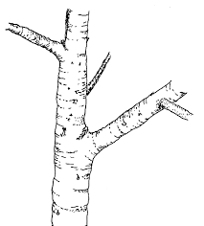**Things used to keep peace and security**

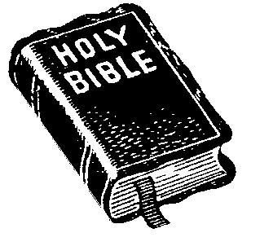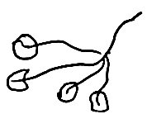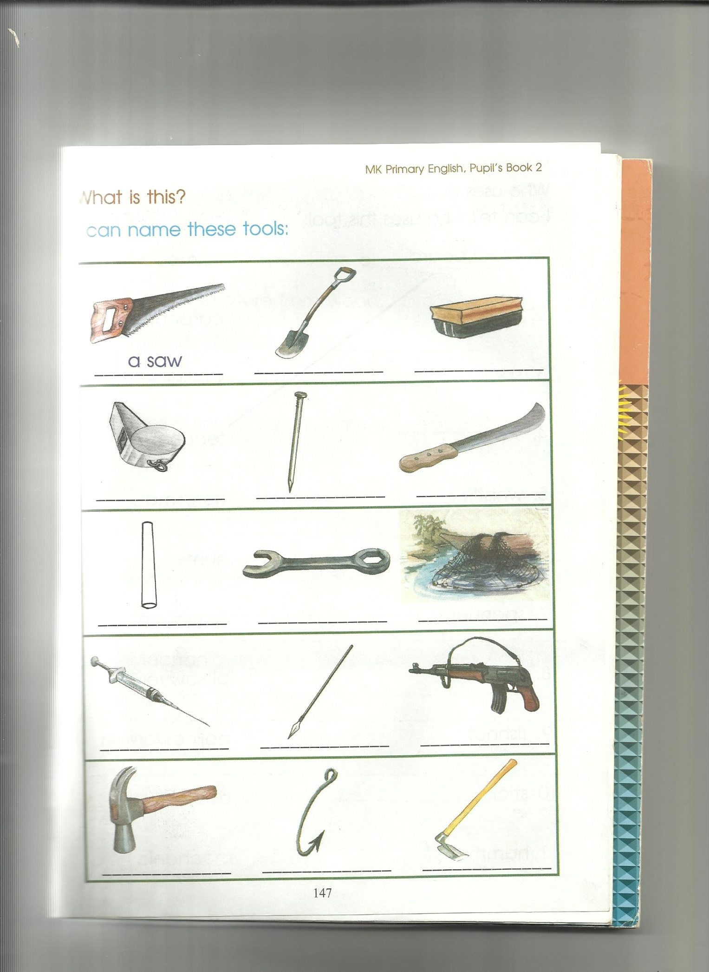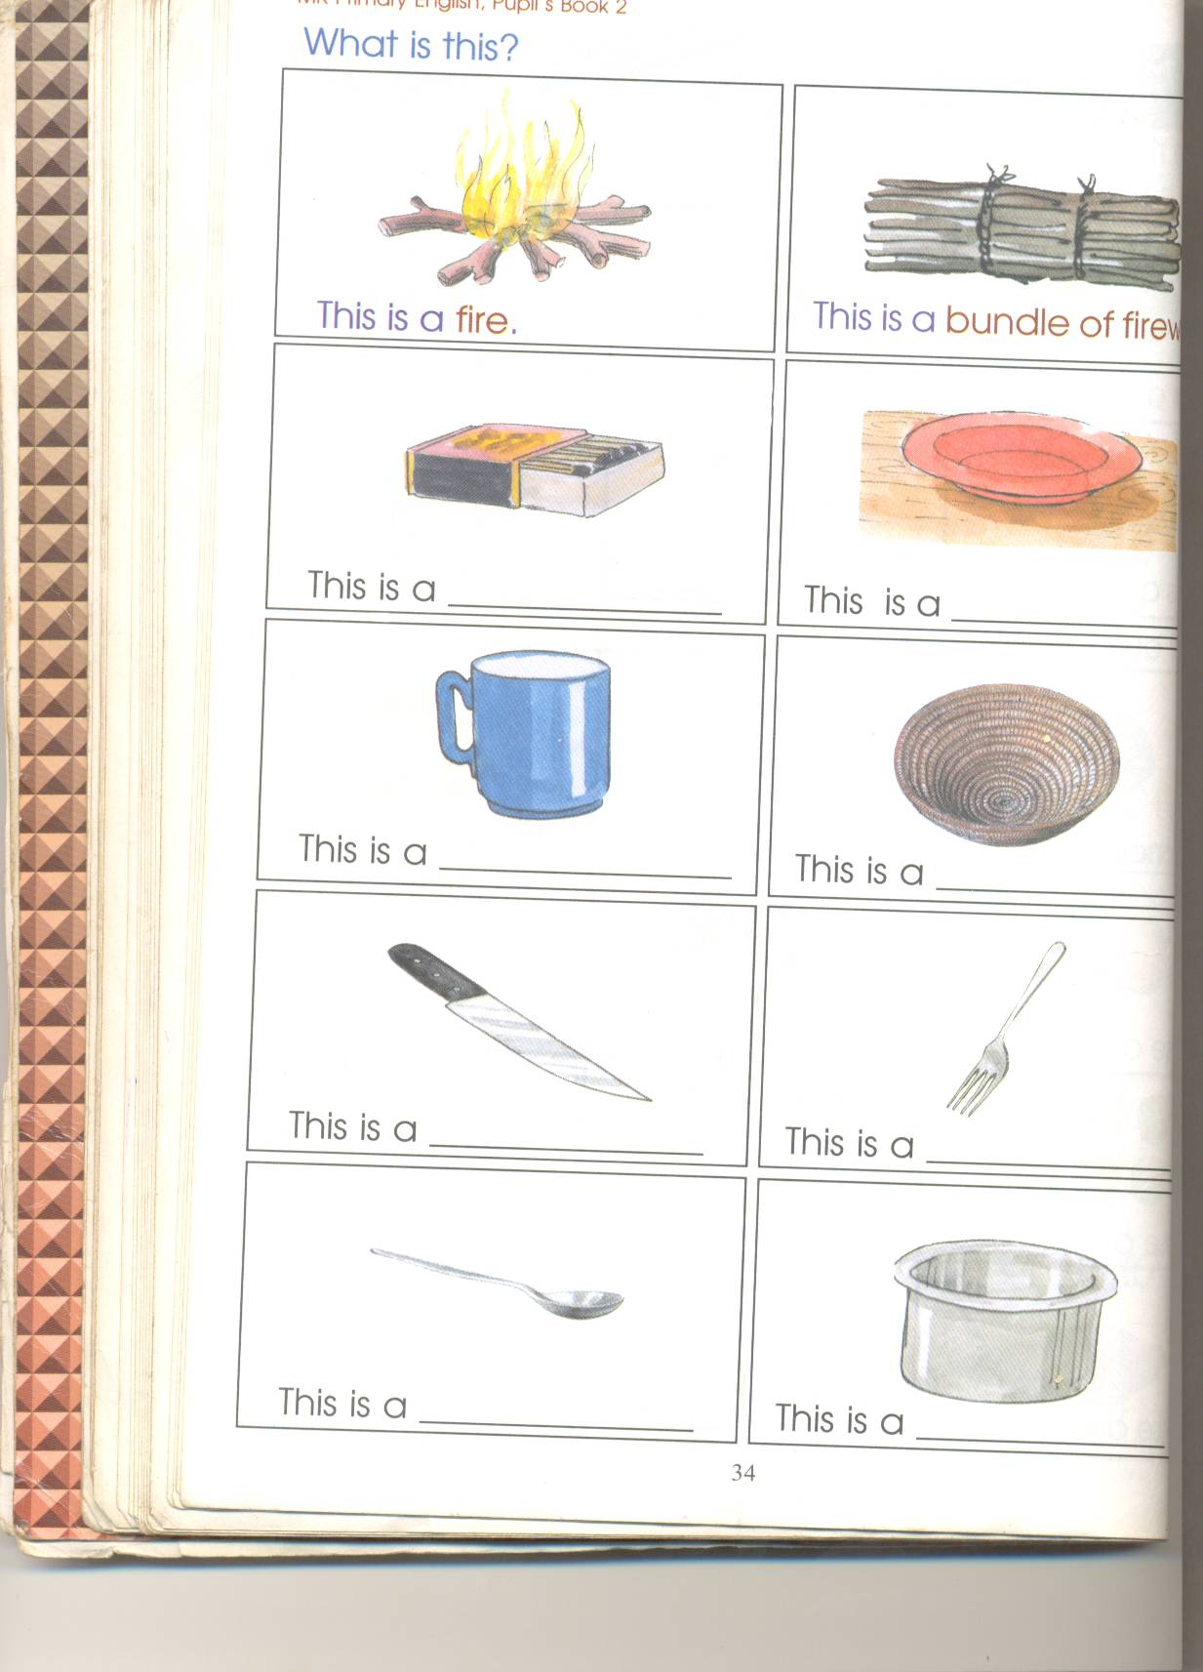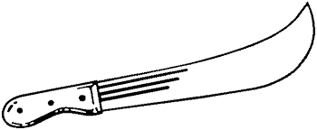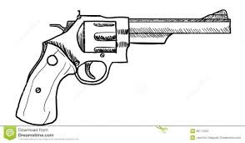

**Working together in the community**

* Cleaning roads
* Caring for others
* Clearing wells
* Sharing

**Taking part in different ceremonies in communities**

* Wedding
* Burial
* Baptism
* Celebration of twins
* Birthdays
* Circumcision

**Topical questions**

1. What is a school?
2. Name people found at school
3. What is the role of the head teacher in a school?
4. List down the school symbols.
5. Identify activities done at school
6. Draw and name the school property
7. How do you keep your school clean
8. Mention things near
9. Identify things found on your school compound
10. Write any buildings found at school.
11. Identify any five
12. List down dangers people meet on the way to and from school.
13. Give any four safe ways to and from school.
14. List down the schools needs.
15. Name any six things you see on the way.

Our home

1. What is a home?
2. Name people found at home.
3. List down things found around your home.
4. Name the people who start a home.
5. Give the roles of these people in a home.
6. Father
7. Mother
8. Children
9. Grand father
10. Identify activities done at home.
11. Mention any four things that good / clean home should have.
12. Draw and name four things found at home.

Plants, birds, animals, granary, rock

1. Write down any four buildings found at home.
2. List down six types of a house.
3. What is a house?
4. Why do people build houses?
5. List down rooms found in a house.
6. Mention any two things found in each room in a house.
7. Give the importance / use of each room in each room.
8. Write the two types of houses.
9. Draw these examples of houses
10. Give any four ways of keeping a house clean.
11. What is a family?
12. Who heads a family?
13. Name the two types of families.
14. ____________ and _________ are my parents.
15. What do you call the father of your parents?
16. Draw and name four building materials.
17. Write the source for these materials.
    * Sand
    * Cement
    * Reed
    * Grass
    * Stones
    * timber
18. Mention any four family needs
19. Identify any four bad people in our families.
    * Nun
    * Thieves
    * Smokers
    * Baby
    * Drunkards
    * Priests
    * defilers

**Our community**

1. A ________________ is a group of people living together.
2. Draw these examples of communities

School, hospital, mosque, church, market

1. Underline important people in our community.

Doctors, thief, teachers, rapists, policemen, Imam.

1. Who keeps law and order?
2. Makes furniture
3. Teaches pupils
4. Flies an aeroplan
5. Mention any four important places in the community.
6. Write the work place for these people.
   * Teachers
   * Doctors
   * Priests
   * Policeman
   * Barber
   * Pilot
   * Farmer
7. Give the importance of these places in our community.
8. School
9. Hospital
10. Saloon
11. Bank
12. Church
13. Circle activities done in our community

Farming, bearing, fishing, stealing, teaching, building

Weather:

1. _______________ is the state/ condition/ change of atmosphere at a given time.
2. List down four types/states/ conditions of weather.
3. State elements / factors/ aspects of weather
4. Mention things used to manage;
5. Sunny weather
6. Rainy weather
7. Windy weather
8. Cloudy weather
9. Give two uses of
10. Sun
11. Rain
12. Wind
13. Clouds
14. List down two dangers of too much;
15. Sunshine
16. Rain
17. wind
18. What is the main natural source of;
19. Water
20. light
21. State two activities done during;
22. Sunny weather
23. Rainy weather
24. Windy weather
25. List down five types of clouds
26. Name the cloud that;
27. Brings rain
28. Highest in the sky
29. Name the types of seasons.
30. In which season do farmers
31. Harvest, water crops and dry seeds?
32. Dig, plant, weed and prun
33. Draw these activities done in a;
34. Dry season
35. Windy season

**Our transport**

1. A ___________________ is the movement of people and goods from one place to another.
2. List down four types of transport
3. Identify two means of ;
4. Air transport
5. Water transport
6. Road transport
7. Railway transport
8. List down four road users
9. What type of transport is;
10. Commonly used by the people?
11. Quickest
12. slowest
13. Draw down places where these transport means are parked.
14. Aeroplane (f) boats
15. Taxis
16. Bus
17. Ship
18. Train
19. Identify people who operate these means;
20. aero plane
21. cars
22. bicycle
23. train
24. boat
25. ship
26. Identify people who operate these means.
27. Aeroplane
28. Cars
29. Bicycle
30. Train
31. Boat
32. Ship

**Things we make (crafts)**

1. What are crafts
2. Who makes crafts
3. Give examples of crafts
4. Write down two crafts we make from these materials.
5. Wood
6. Clay
7. Plastic
8. Banana fibre
9. Why do people make crafts?
10. State any six sources of materials used to make crafts
11. ______________ are things we make using our hands.

**Peace and security**

1. What is
2. Peace
3. Security
4. Identify any four people who keep peace and security
5. At home
6. In the community
7. Give the roles of these people in keeping peace and security
8. Parents
9. Police
10. Religious leaders
11. Children
12. Teachers
13. Give any four examples of religious leaders.
14. State factors that promotes peace and security.
15. In our home.
16. At school
17. In the community
18. What is insecurity?
19. What causes insecurity?
20. In our homes
21. Schools
22. community
23. List down any four effects of insecurity.
24. Draw these tools used to keep peace and security

Gun, bow and arrows, pistol, spears, panga, sticks

1. Give any two importance of keeping peace and security.

**END**